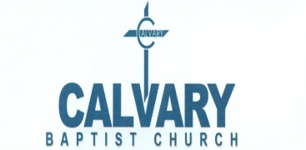Ministry Opportunity Event Checklist
Rev. Corey B. Gibson, M.Div.
____________________________________
Ministry Name

Date Request Submitted: __________

Event Date: _______________ /Event Time:____________ /___/

Event Name: ______________________________________ /___/

Purpose of Event:______________________________________ /___/

Estimated number of attendees: ____ /___/

Number of tables requested: _____ /___/

Color(s) Requested: _________________________

Programs Requested: Office: ____ Outside Entity: _____ (Check One)
*All program drafts must be submitted 2 weeks prior for Review & approval.*

Additional comments:_________________________________________________
___________________________________________________________________

Request for Sanctuary: Yes: ☐ No: ☐
Request for Ushers : Yes: ☐ No: ☐
Request for A/V System in the Sanctuary: Yes: ☐ No: ☐

Request for Music Ministry: Yes: ☐ No: ☐

Request for Fellowship Hall/LT Boyce Chapel (circle one): Yes: ☐ No: ☐
Microphone Request: Yes: ☐ No: ☐

Request for transportation: Yes: ☐ No: ☐**Submit request 60 days prior to event**

Form must be returned to the office 60 days in advance to ensure your request(s) be honored in a timely manner.

Ministry Director Signature:________________________________ Date: _______

Church Admin/Office Staff Signature:_________________________ Date: ______

cc: Media Ministry / Music Ministry / Ushers / Transportation Ministry
(Updated 01/01/25)

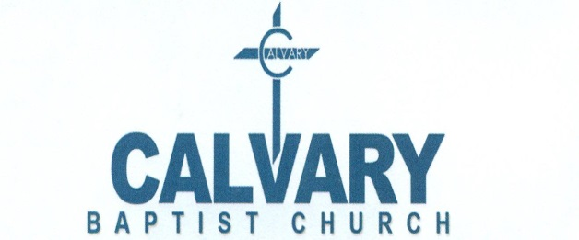

Rev. Corey B. Gibson, M.Div.

Media Ministry

ATTENTION ALL MINISTRY DIRECTORS

In order for the Media Ministry to provide you with excellent service, it is a MUST that you complete the Ministry Opportunity Checklist and return to the office for approval 60 days (2 months) in advance.

This allows us time to review your request and reach out to you to address any questions or concerns that we or you may have.

Forms are available in the mail slot by the office door and a copy will be provided to you after it has been reviewed.

Thank you,

Media Ministry

